Mid-Term Question Solutions
Department of Computer Science and Engineering, University of Barishal
Instructor: Dr. Md. Manjur Ahmed
Paper A: Theory of Computation, 1st Mid (50 marks, 50 min)
Paper B: Automata Theory, Mid-Term Exam 2, 8 Oct 2024 (50 marks, 45 min)
Notation: Σ = alphabet, Σ* = all strings over Σ, ε = empty string, δ = transition function, F = set of accepting states. Marks for Paper B are as read from the photographed paper.

Question categorization

Paper A: Theory of Computation
Q | Question | Topic | Subtopic | Marks
1 | Automata theory; applications of FA | Introduction to Automata Theory | Basic concepts; applications of finite automata | 6
2 | Lexical analyzer with on/off switch | Finite Automata (applications) | Lexical analysis; FA as a model of a device | 3
3 | Theorems, lemmas, corollaries | Mathematical Preliminaries | Proof terminology | 6
4 | NFA: first symbol appears again | Nondeterministic Finite Automata | NFA design (guess and verify) | 5
5 | NFA: strings ending in 101 | Nondeterministic Finite Automata | NFA design (pattern at the end) | 10
6 | Convert NFA of Q5 to DFA | Equivalence of NFA and DFA | Subset construction | 5
7 | ε-NFA: empty or ends in 11 | ε-NFA | ε-NFA design; ε-transitions | 5
8 | Convert ε-NFA of Q7 to DFA | Equivalence of ε-NFA and DFA | ε-closure; subset construction | 10

Paper B: Automata Theory
Q | Question | Topic | Subtopic | Marks
1 | Define PDA with example | Pushdown Automata | Formal definition; example | 5
2 | PDAs: ≥ three 1s; odd palindromes | Pushdown Automata | PDA design (regular language; palindromes) | 8
3 | Pumping lemma: 0^{2n}1^{3n}0^{n} | Context-Free Languages | Pumping lemma for CFLs; non-CFL proof | 10
4 | Regular ∪ finite set is regular | Regular Languages | Closure under union; finite languages | 8
5 | Closure properties of regular languages | Regular Languages | Closure properties and constructions | 5
6 | Does a PDA have memory? | Pushdown Automata | Stack as memory; computational power | 4

Paper A: Theory of Computation

Q1. Automata theory and applications of finite automata
Topic: Introduction to Automata Theory | Subtopic: Basic concepts; applications of FA | Marks: 6
Automata theory is the branch of theoretical computer science that studies abstract machines (automata) and the problems they can solve. It gives mathematical models of computation and links machines to formal languages and grammars. A language is a set of strings, L ⊆ Σ*.
A finite automaton is a 5-tuple M = (Q, Σ, δ, q₀, F): a finite set of states Q, input alphabet Σ, transition function δ: Q × Σ → Q, start state q₀ ∈ Q and accepting states F ⊆ Q. M accepts w if δ*(q₀, w) ∈ F.
Language class | Machine | Grammar
Regular | Finite automaton (DFA/NFA) | Regular
Context-free | Pushdown automaton | Context-free
Context-sensitive | Linear-bounded automaton | Context-sensitive
Recursively enumerable | Turing machine | Unrestricted

Applications of finite automata
- Compilers: lexical analysis; tokens are recognized by DFAs built from regular expressions.
- Text search and pattern matching: grep, find-and-replace, string matching (e.g. KMP), regular-expression engines.
- Hardware design: sequential circuits, counters and controllers are state machines.
- Protocol and system modelling: network protocols, vending machines, elevators, traffic lights.
- Verification: model checking of software and hardware uses finite-state models.
- Natural language and input validation: spell checking, morphology, validating emails, numbers and forms.
- Games and UI: character behaviour and dialog flows as state machines.

Q2. Lexical analyzer with an on/off switch
Topic: Finite Automata (applications) | Subtopic: Lexical analysis; FA as a model of a device | Marks: 3
A lexical analyzer (scanner) is the first phase of a compiler. It reads the source text one character at a time, groups characters into lexemes and outputs tokens (keyword, identifier, number, operator), skipping whitespace and comments. It is implemented as a DFA: regular expression → NFA → DFA → scanner. Each input character moves the DFA to a new state; reaching an accepting state means a token has been recognized.
The simplest automaton is the on/off switch. It has two states and one input, push, and remembers one bit: whether the switch is on or off.
M = ({off, on}, {push}, δ, off, {on}), δ(off, push) = on, δ(on, push) = off
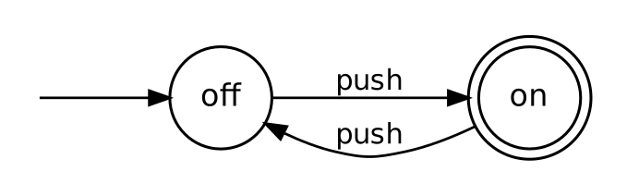
Fig. 1: Finite automaton for an on/off switch
The scanner works the same way. A keyword recognizer for the tokens on and off reads characters and changes state; the accepting state reached tells which token to emit.
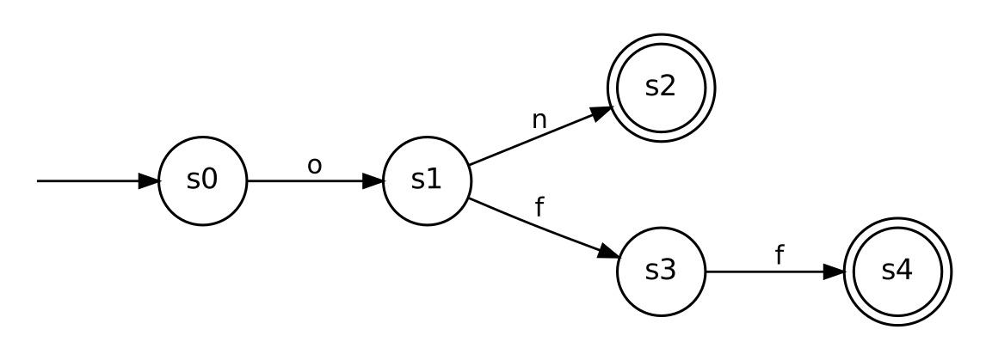
Fig. 2: Scanner fragment recognizing the keywords on (s2) and off (s4)
Trace for input “off”: s0 →(o) s1 →(f) s3 →(f) s4. The state s4 is accepting, so the token OFF is emitted and the scanner restarts from s0.

Q3. Theorems, lemmas and corollaries
Topic: Mathematical Preliminaries | Subtopic: Proof terminology | Marks: 6
All three are mathematical statements that are proved; they differ in role.
Term | Meaning | Role | Example in automata theory
Theorem | A significant statement proved from axioms and earlier results. | Main result. | Every NFA has an equivalent DFA (subset construction).
Lemma | A smaller proved statement used as a step toward a theorem. | Helper result; some are important in their own right. | Pumping lemma for regular languages; Arden’s lemma.
Corollary | A statement that follows almost immediately from a theorem or lemma. | Direct consequence; needs little or no new proof. | A language accepted by an NFA is regular.

Relation: Lemma ⟹ Theorem ⟹ Corollary. Lemmas are proved first and used to prove the theorem; corollaries are then derived from it.
Analysis: a theorem is judged by its importance, a lemma by its usefulness in a proof, and a corollary by how directly it follows. The labels reflect a result’s role, not its difficulty: the pumping lemma is called a lemma yet is a standard tool for proving non-regularity.

Q4. NFA: first symbol appears again later
Topic: Nondeterministic Finite Automata | Subtopic: NFA design (guess and verify) | Marks: 5
Σ = {0, 1}. L = { w | the first symbol of w occurs at least once more in w }. The NFA remembers the first symbol by choosing a branch, then guesses which later occurrence matches it.
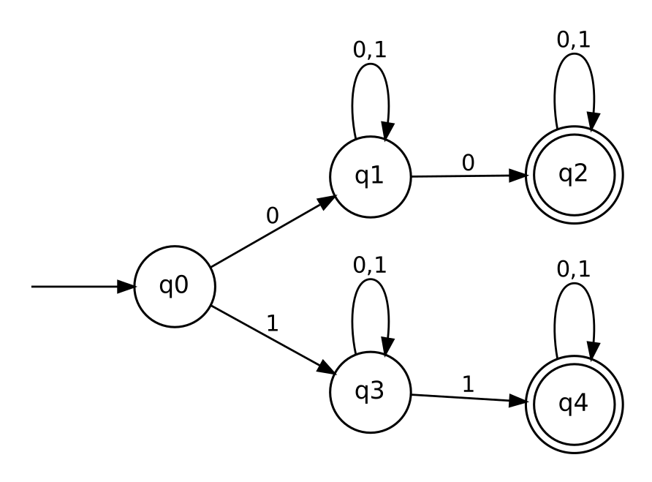
Fig. 3: NFA for strings whose first symbol reappears
N = (Q, {0,1}, δ, q₀, F), Q = {q₀, q₁, q₂, q₃, q₄}, F = {q₂, q₄}. Upper branch (q₁, q₂): first symbol 0. Lower branch (q₃, q₄): first symbol 1.
δ | 0 | 1
→ q₀ | {q₁} | {q₃}
q₁ | {q₁, q₂} | {q₁}
* q₂ | {q₂} | {q₂}
q₃ | {q₃} | {q₃, q₄}
* q₄ | {q₄} | {q₄}

Regular expression: 0(0+1)*0(0+1)* + 1(0+1)*1(0+1)*. Check: 010 is accepted (q₀, q₁, q₁, q₂); 011 is rejected (the 0-branch never sees a second 0); 1001 is accepted via q₃, q₃, q₃, q₄.

Q5. NFA for L = { w | w ends in 101 }
Topic: Nondeterministic Finite Automata | Subtopic: NFA design (pattern at the end) | Marks: 10
Idea: q₀ loops on every symbol; on a 1 the NFA may guess that the final 101 starts here, then verifies 1, 0, 1 in order.
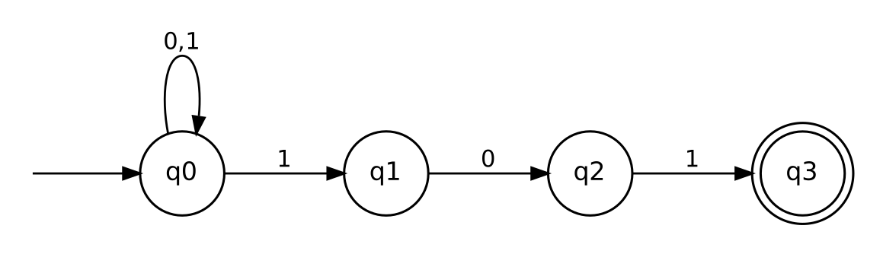
Fig. 4: NFA for strings ending in 101
N = (Q, {0,1}, δ, q₀, {q₃}), Q = {q₀, q₁, q₂, q₃}. Regular expression: (0+1)*101.
δ | 0 | 1
→ q₀ | {q₀} | {q₀, q₁}
q₁ | {q₂} | ∅
q₂ | ∅ | {q₃}
* q₃ | ∅ | ∅

Check on 1101: q₀ –1→ q₀ –1→ q₁ –0→ q₂ –1→ q₃, accepted. The guess is wrong on other paths, which simply die.

Q6. Convert the NFA of Q5 to a DFA
Topic: Equivalence of NFA and DFA | Subtopic: Subset construction | Marks: 5
Subset construction: each DFA state is a set of NFA states; δ_{D}(S, a) = ∪_{q∈S} δ_{N}(q, a); the start state is {q₀}; a set is accepting if it contains q₃. Only reachable subsets are built (4 of the possible 2⁴ = 16).
DFA state | On 0 | On 1
→ A = {q₀} | {q₀} = A | {q₀, q₁} = B
B = {q₀, q₁} | {q₀, q₂} = C | {q₀, q₁} = B
C = {q₀, q₂} | {q₀} = A | {q₀, q₁, q₃} = D
* D = {q₀, q₁, q₃} | {q₀, q₂} = C | {q₀, q₁} = B

Example: δ_{D}(C, 1) = δ_{N}(q₀, 1) ∪ δ_{N}(q₂, 1) = {q₀, q₁} ∪ {q₃} = {q₀, q₁, q₃}.
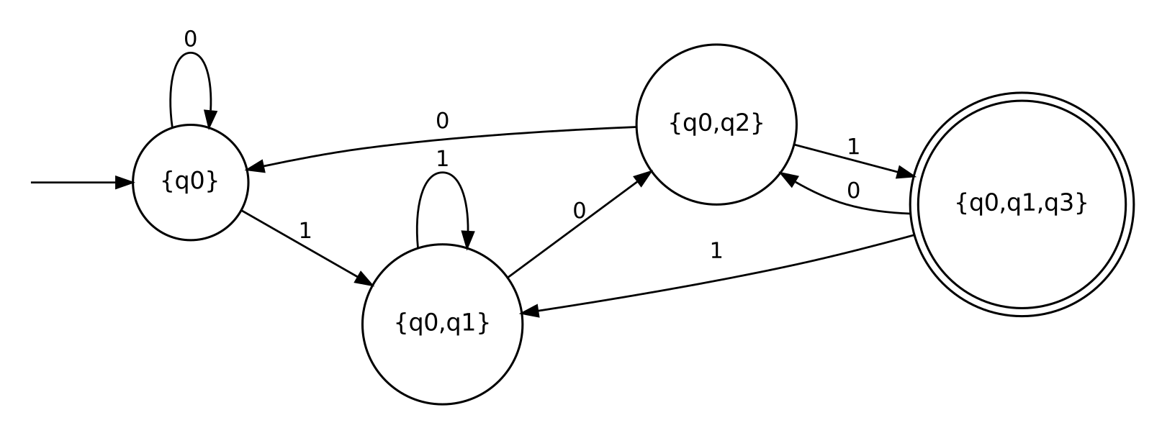
Fig. 5: DFA equivalent to the NFA of Q5 (accepting state D contains q3)
Check: 101 gives A → B → C → D, accepted; 1011 gives D → B, rejected.

Q7. ε-NFA for L = { w | w is empty, or ends in 11 }
Topic: ε-NFA | Subtopic: ε-NFA design; ε-transitions | Marks: 5
L = {ε} ∪ Σ*11. The start state q₀ is accepting, which accepts ε. An ε-transition moves from q₀ to q₁, which loops on 0, 1 and guesses the start of the final 11.
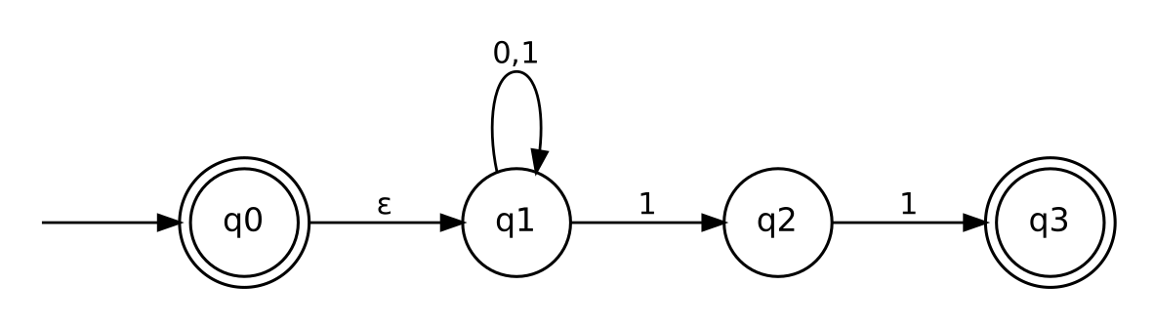
Fig. 6: ε-NFA for the empty string or strings ending in 11
E = (Q, {0,1}, δ, q₀, {q₀, q₃}), Q = {q₀, q₁, q₂, q₃}.
δ | 0 | 1 | ε
→ * q₀ | ∅ | ∅ | {q₁}
q₁ | {q₁} | {q₁, q₂} | ∅
q₂ | ∅ | {q₃} | ∅
* q₃ | ∅ | ∅ | ∅

Q8. Convert the ε-NFA of Q7 to a DFA
Topic: Equivalence of ε-NFA and DFA | Subtopic: ε-closure; subset construction | Marks: 10
Step 1: ε-closures (states reachable using ε-moves only).
State | ECLOSE
q₀ | {q₀, q₁}
q₁ | {q₁}
q₂ | {q₂}
q₃ | {q₃}

Step 2: subset construction. Start state = ECLOSE(q₀) = {q₀, q₁}. For a set S: δ_{D}(S, a) = ECLOSE( ∪_{q∈S} δ(q, a) ). A set is accepting if it contains q₀ or q₃.
DFA state | On 0 | On 1
→ * A = {q₀, q₁} | ECLOSE{q₁} = {q₁} = B | ECLOSE{q₁, q₂} = {q₁, q₂} = C
B = {q₁} | {q₁} = B | {q₁, q₂} = C
C = {q₁, q₂} | {q₁} = B | ECLOSE{q₁, q₂, q₃} = D
* D = {q₁, q₂, q₃} | {q₁} = B | {q₁, q₂, q₃} = D

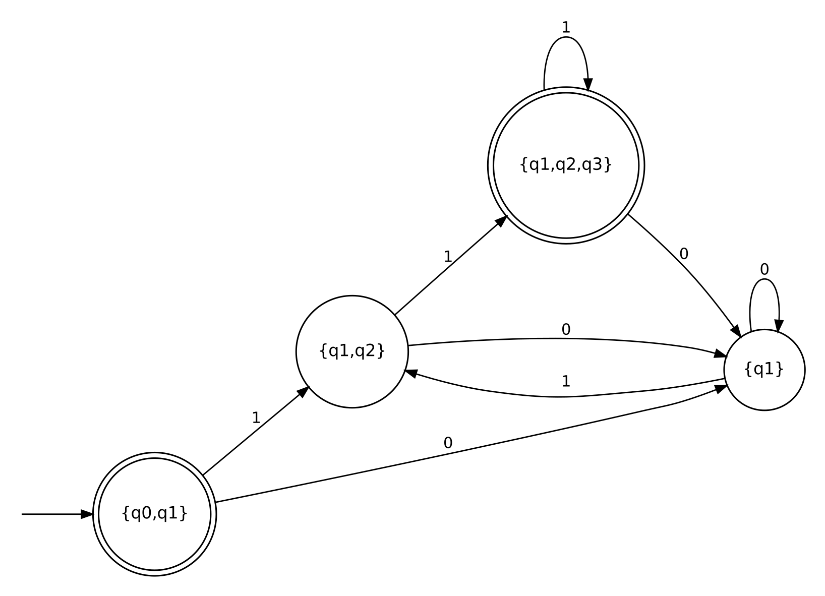
Fig. 7: DFA equivalent to the ε-NFA of Q7 (accepting states A and D)
Check: ε is accepted (A is accepting); 011 gives A → B → C → D, accepted; 110 gives D → B, rejected; 1 gives C, rejected.

Paper B: Automata Theory

Q1. Pushdown automaton: definition and example
Topic: Pushdown Automata | Subtopic: Formal definition; example | Marks: 5
A pushdown automaton (PDA) is an ε-NFA equipped with a stack. It recognizes exactly the context-free languages. Formally, P = (Q, Σ, Γ, δ, q₀, F) where:
- Q is a finite set of states; Σ is the input alphabet; Γ is the stack alphabet;
- δ: Q × Σ_{ε} × Γ_{ε} → P(Q × Γ_{ε}) (P = power set) is the transition function, with Σ_{ε} = Σ ∪ {ε}, Γ_{ε} = Γ ∪ {ε};
- q₀ ∈ Q is the start state and F ⊆ Q is the set of accepting states.
An arc labelled a, b → c means: read a from the input, pop b from the stack, push c. ε in any position means “nothing”.
Example: L = { 0^{n}1^{n} | n ≥ 0 }. Push $ as a bottom marker, push a 0 for every 0 read, pop a 0 for every 1 read, and accept when only $ is left.
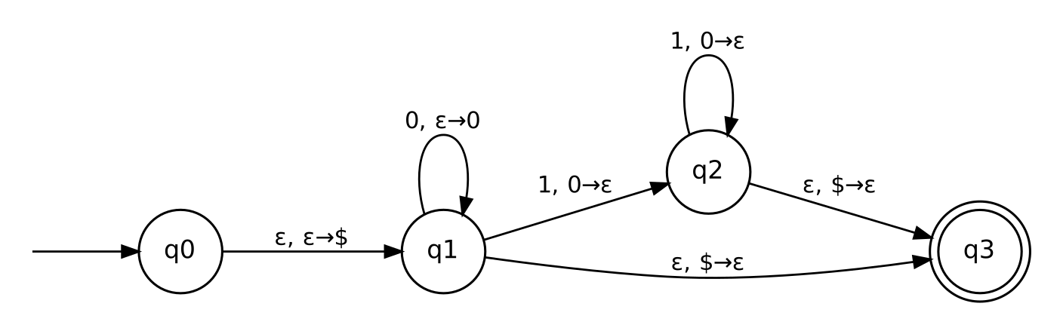
Fig. 8: PDA for {0^n 1^n | n ≥ 0}
Trace for 0011: push $; read 0, push 0; read 0, push 0 (stack $00); read 1, pop 0; read 1, pop 0 (stack $); ε-move pops $ into the accepting state q₃. For 001, the stack still holds a 0 at the end, so $ is not on top and the input is rejected.

Q2. PDAs for two languages
Topic: Pushdown Automata | Subtopic: PDA design (regular language; palindromes) | Marks: 8

(a) A = { w ∈ {0,1}* | w contains at least three 1s }
A is regular, so the stack is not needed. The states count the 1s seen so far (0, 1, 2, ≥ 3) and the stack is left unchanged on every move (a, ε → ε).
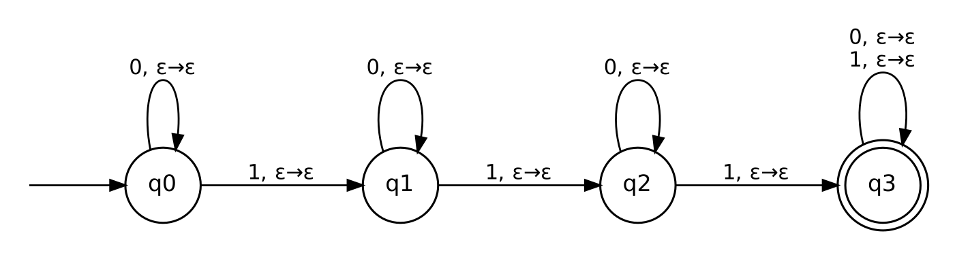
Fig. 9: PDA accepting strings with at least three 1s
P = ({q₀, q₁, q₂, q₃}, {0,1}, {$}, δ, q₀, {q₃}). q_{i} means “i ones read” (q₃: three or more). Regular expression: 0*10*10*1(0+1)*.

(b) B = { w ∈ {0,1}* | w = w^{R} and |w| is odd }
B is the set of odd-length palindromes. The PDA pushes the first half onto the stack, guesses the middle symbol and skips it, then pops one stack symbol per input symbol, which must match (the second half read forward equals the first half reversed).
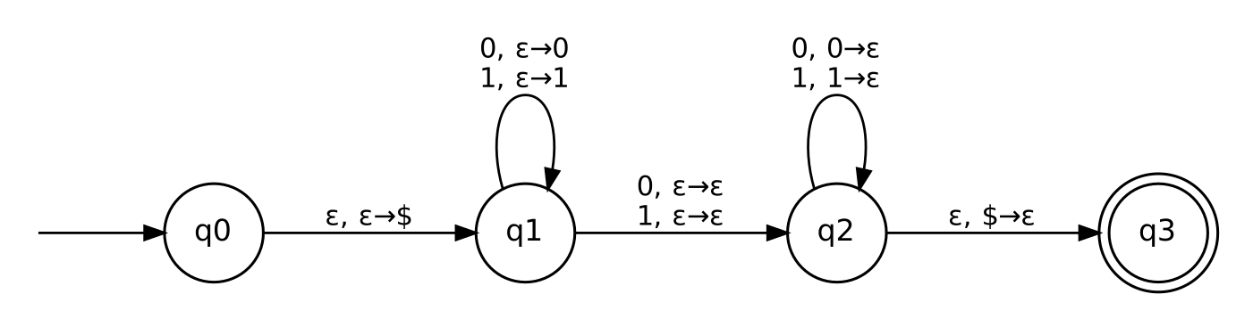
Fig. 10: PDA for odd-length palindromes
P = ({q₀, q₁, q₂, q₃}, {0,1}, {0,1,$}, δ, q₀, {q₃}). Moves:
- q₀ → q₁: ε, ε → $ (mark the bottom of the stack).
- q₁: a, ε → a for a ∈ {0,1} (push the first half).
- q₁ → q₂: a, ε → ε (read the middle symbol, no stack change; this is the nondeterministic guess).
- q₂: a, a → ε (read a, pop a; mismatch means the branch dies).
- q₂ → q₃: ε, $ → ε (stack empty, so the halves had equal length).
Check 01010: push 0, 1; middle 0; read 1 (pop 1), read 0 (pop 0); pop $; accept. For an even-length input, the middle step uses one symbol and the halves differ in length, so no branch accepts. ε is rejected because a middle symbol is required.

Q3. Pumping lemma: A = { 0^{2n} 1^{3n} 0^{n} | n ≥ 0 } is not context-free
Topic: Context-Free Languages | Subtopic: Pumping lemma for CFLs; non-CFL proof | Marks: 10
Pumping lemma for CFLs. If A is context-free, there is a pumping length p ≥ 1 such that every s ∈ A with |s| ≥ p can be written s = uvxyz with
- |vy| > 0,
- |vxy| ≤ p,
- uv^{i}xy^{i}z ∈ A for every i ≥ 0.
Proof by contradiction. Assume A is context-free with pumping length p. Choose
s = 0^{2p} 1^{3p} 0^{p} ∈ A (n = p), |s| = 6p ≥ p.
Write s = uvxyz satisfying (1)–(3). Call 0^{2p} the first block, 1^{3p} the middle block, and 0^{p} the last block.
Key fact. If vxy touched both the first and last blocks, it would contain the whole middle block plus one symbol on each side, so |vxy| ≥ 3p + 2 > p, contradicting (2). Hence vxy misses the first block or misses the last block.
Pump with i = 2: s′ = uv²xy²z, whose length is |s′| = 6p + |vy| > 6p.
Case A: vxy misses the last block (it lies in the first and/or middle block). Then s′ still ends with 1…10^{p}, so its final run of 0s has length p. If s′ ∈ A, then s′ = 0^{2m}1^{3m}0^{m} for some m, and its last run gives m = p. But then |s′| = 6m = 6p.
Case B: vxy misses the first block (it lies in the middle and/or last block). Then s′ still begins with 0^{2p}1, so its first run of 0s has length 2p. If s′ ∈ A, then 2m = 2p, so m = p and |s′| = 6p.
In both cases |s′| = 6p, contradicting |s′| = 6p + |vy| > 6p. (If the pumped string is not even of the form 0*1*0*, it is not in A either.) Therefore s′ ∉ A, which contradicts condition (3). Hence A is not context-free. ∎
Position of vxy | Effect of pumping up (i = 2)
Inside the first block | More than 2p leading 0s, while 1s and last 0s stay 3p and p
Inside the middle block | More than 3p 1s, while 2p and p stay
Inside the last block | More than p trailing 0s, while 2p and 3p stay
Across first and middle | Last block stays p, but the first two blocks no longer total 5p
Across middle and last | First block stays 2p, but the last two blocks no longer total 4p

Q4. Adding a finite set of strings to a regular language
Topic: Regular Languages | Subtopic: Closure under union; finite languages | Marks: 8
Claim. If L is regular and F is a finite set of strings, then L ∪ F is regular.
Proof. Let F = {w₁, …, w_{m}}.
Step 1: a single string is regular. For w = a₁a₂…a_{k}, the NFA below has states q₀, …, q_{k}, δ(q_{i−1}, a_{i}) = q_{i} and F = {q_{k}}. It accepts only w. (For w = ε, take one accepting start state.)
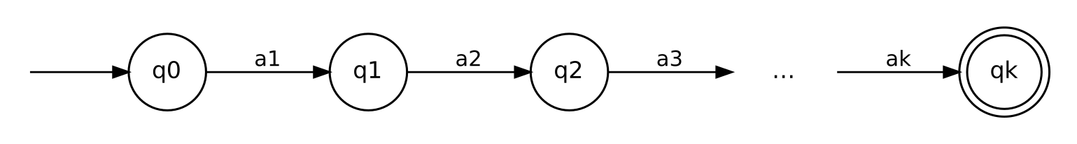
Fig. 11: NFA accepting the single string a1a2…ak
Step 2: F is regular. F = {w₁} ∪ … ∪ {w_{m}}. By induction on m: the empty language ∅ is regular (m = 0); if {w₁, …, w_{m−1}} is regular, then adding {w_{m}} is a union of two regular languages, which is regular by closure under union (Step 3 below).
Step 3: union of two regular languages. Let N_{L} = (Q₁, Σ, δ₁, s₁, F₁) accept L and N_{F} = (Q₂, Σ, δ₂, s₂, F₂) accept F, with disjoint states. Define
N = (Q₁ ∪ Q₂ ∪ {s₀}, Σ, δ, s₀, F₁ ∪ F₂), δ(s₀, ε) = {s₁, s₂}
and δ = δ₁ or δ₂ on the states of N_{L} or N_{F}. A string w is accepted by N iff the machine moves by ε to s₁ or s₂ and then accepts, i.e. iff w ∈ L or w ∈ F. So L(N) = L ∪ F.
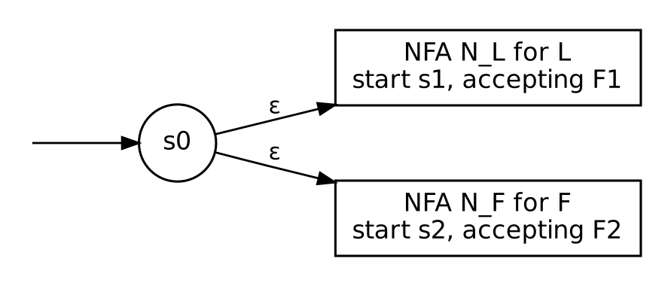
Fig. 12: Union construction N for L ∪ F
Since N is an ε-NFA and every ε-NFA accepts a regular language, L ∪ F is regular. ∎
Regular-expression view: if L = L(R), then L ∪ F = L(R + w₁ + … + w_{m}), which is a regular expression.

Q5. Closure properties of regular languages
Topic: Regular Languages | Subtopic: Closure properties and constructions | Marks: 5
If L₁ and L₂ are regular languages over Σ, the following are also regular:
Operation | Result | Construction
Union | L₁ ∪ L₂ | New start state with ε-moves to both start states; or regex R₁ + R₂.
Intersection | L₁ ∩ L₂ | Product DFA: Q₁ × Q₂, δ((p,q), a) = (δ₁(p,a), δ₂(q,a)), F = F₁ × F₂.
Complement | Σ* ∖ L₁ | For a complete DFA, F′ = Q ∖ F.
Difference | L₁ ∖ L₂ | L₁ ∩ (Σ* ∖ L₂).
Concatenation | L₁L₂ | ε-moves from each state in F₁ to the start state of the second machine.
Kleene star | L₁* | New accepting start state; ε-moves from each state in F₁ back to the start.
Reversal | L₁^{R} | Reverse all arcs; swap start and accepting roles (new start with ε-moves to old accepting states).
Homomorphism | h(L₁) | Replace each symbol a in the regex or automaton by the string h(a).
Inverse homomorphism | h⁻¹(L₁) | DFA with δ′(q, a) = δ*(q, h(a)).
Quotient | L₁ / L₂ | Accept state q if some string of L₂ leads from q to F₁.

Regular languages are closed under these finitely many applications only: they are not closed under infinite union. For example, each {0^{n}1^{n}} slice is a single string (regular), yet the union over all n is {0^{n}1^{n} | n ≥ 0}, which is not regular.

Q6. Does a pushdown automaton have memory?
Topic: Pushdown Automata | Subtopic: Stack as memory; computational power | Marks: 4
Yes. A PDA has two kinds of memory: the finite control (its current state) and a stack of unbounded size. The stack is what separates a PDA from a finite automaton.
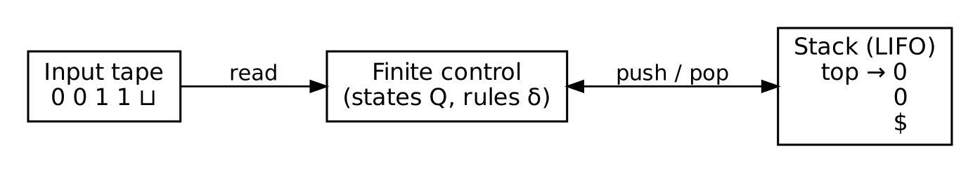
Fig. 13: Structure of a pushdown automaton
Justification:
- A configuration is (q, w, γ): the state, the unread input and the stack contents. The stack contents γ persist across moves, so earlier input can influence later decisions.
- To accept {0^{n}1^{n}}, the machine must remember n, which can be arbitrarily large. A DFA has only finitely many states and cannot (pumping lemma), but a PDA stores n as the stack height.
- The same memory lets a PDA match nested structure, such as palindromes w w^{R} or balanced parentheses.
Limits: the memory is last-in, first-out. Only the top symbol can be read, and reading it removes it, so a PDA cannot compare two independent counts. It cannot accept {0^{n}1^{n}2^{n}}, which is not context-free.
Machine | Memory
Finite automaton | Finite: only the current state
Pushdown automaton | State plus an unbounded stack (LIFO access)
Turing machine | State plus an unbounded tape (random access)

